**Quarterly Report – Public Page**

**Date of Report:** 10th Quarterly Report - April 1, 2025

**Contract Number:** *693JK32210015POTA*

**Prepared for:** *DOT-PHMSA*

**Project Title:** *Dynamic Geohazard Risk and Decision Support Platform*

**Prepared by:**  *Boston Geospatial, Inc.*

**Contact Information:**  *Justin Oliveira,* [*justin@bostongeospatial.com*](mailto:justin@bostongeospatial.com)*, 321-720-3568*

**For quarterly period ending:** *March 31, 2025*

**1: Items Completed During this Quarterly Period:**

A detailed overview of the progress this past quarter is provided in the various sections below.

| ***Item #*** | ***Task #*** | ***Activity/Deliverable*** | ***Title*** |
| --- | --- | --- | --- |
| - | 0.1 | 10th Quarterly Status Report | Submit 10th quarterly report |

**2: Items Not-Completed During this Quarterly Period:**

| ***Item #*** | ***Task #*** | ***Activity/Deliverable*** | ***Title*** |
| --- | --- | --- | --- |
| 26 | 8.1 | Backtesting | Backtesting of tool with TAP operators |
| 28 | 8.1 | Backtesting | Backtesting of tool with TAP operators |

**3: Project Financial Tracking During this Quarterly Period:**

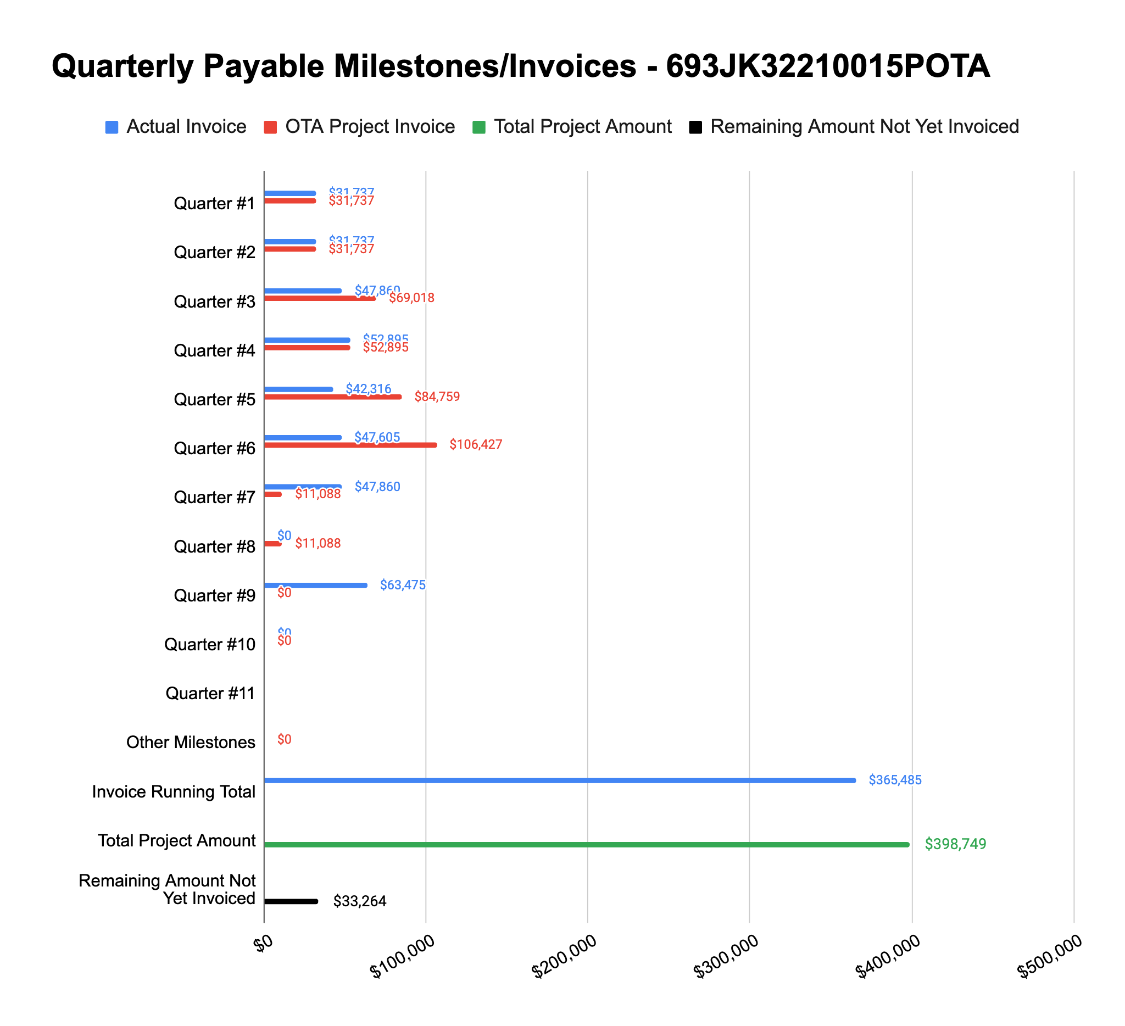

**4: Project Technical Status –**

**Item# 26 / Task# 8.1/ Integration / Backtesting of tool with TAP operators**

Work with the operators is progressing, however we are still waiting on data files from Operator #1 along with other key information. The source of the delay there has (we believe) primarily been the bandwidth of our POC. We hope to get back on track with him here in the coming weeks. Progressions of efforts with Operator #2 were delayed slightly a couple weeks back as we wait for their latest LiDAR data. We just received that new LiDAR data the other day and are now in the process of post-processing it for use with their survey. We anticipate that sometime in April we will have an initial tool run complete and will have shared the initial results with Operator #2.

**Item# 28 / Task# 8.1/ Integration / Backtesting of tool with TAP operators**

Please refer to our comments in the Item 26 section above.

**Item# – / Task# 0.1/ 9th Quarterly Status Report / Submit 9th quarterly report**

Additional detail not necessary - this report constitutes the deliverable for Item# – / Task# 0.1.

**5: Project Schedule –**

Overall our project is slightly behind schedule. The backtesting with the first two operators is taking longer than expected due to the time it is taking to coordinate and conduct data and technical interchanges with the operators. We should have enough time to finish the backtesting with our two primary operators prior to the end of July.